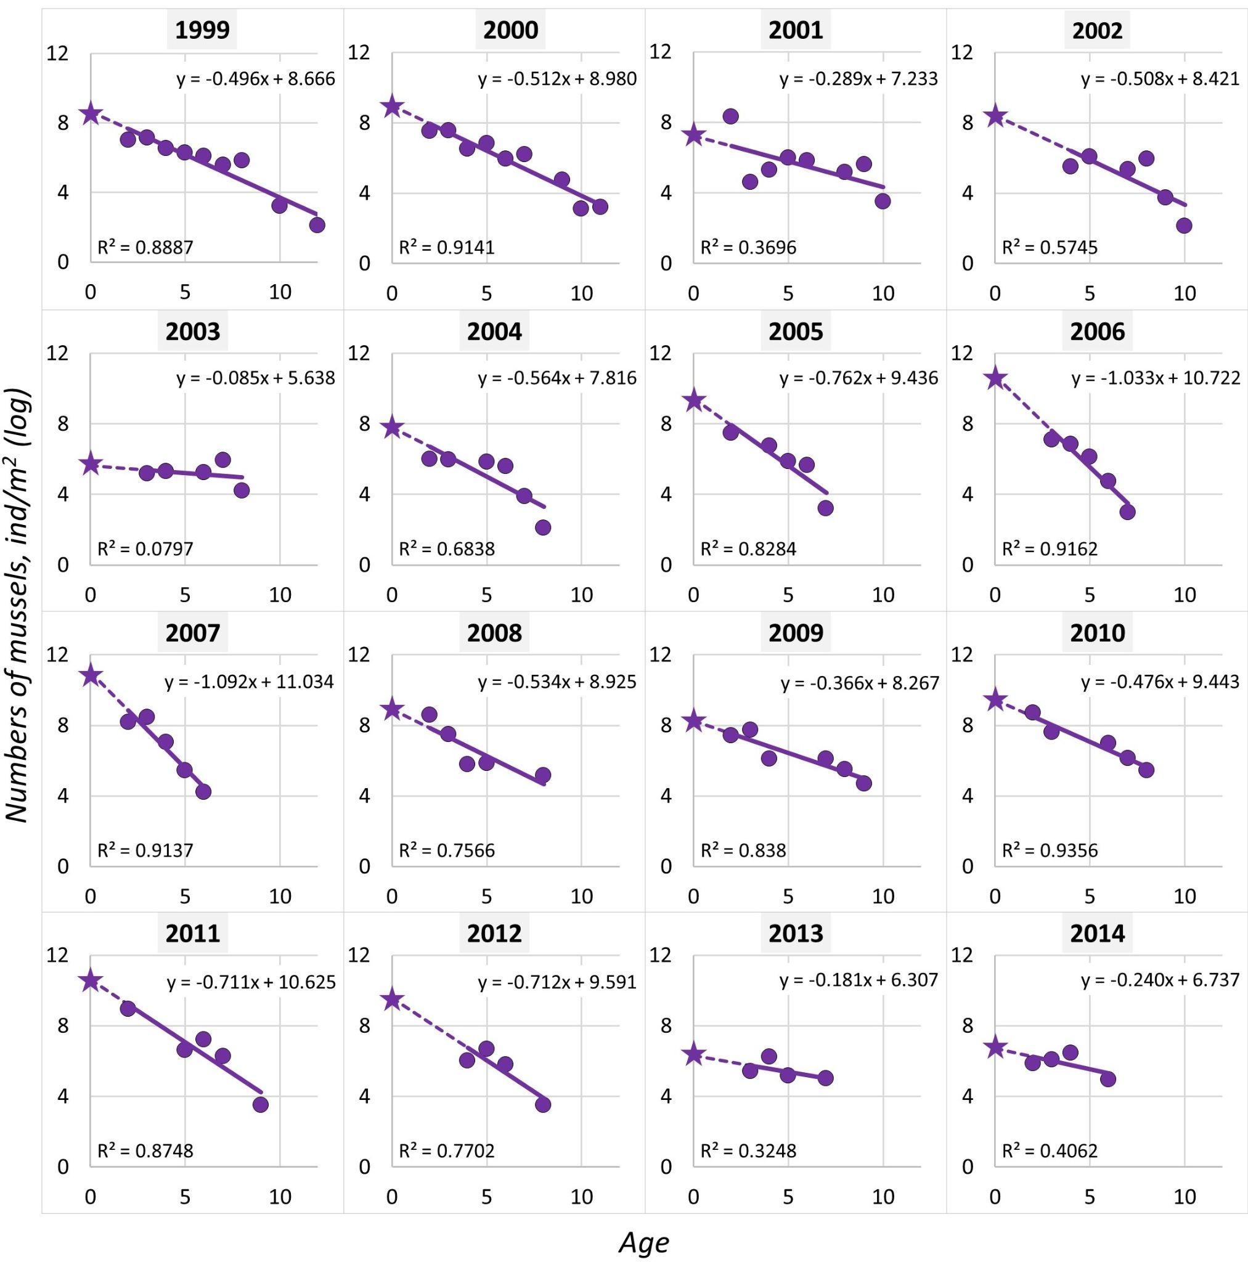

**Figure S1. Survivorship curves for the 1999-2014 generations**. Dots are observed numbers, lines are regressions. Asterisks label *N0*. Equations of linear models (y = *z*\*x + *N0*) and coefficients of determination (R2) are given.

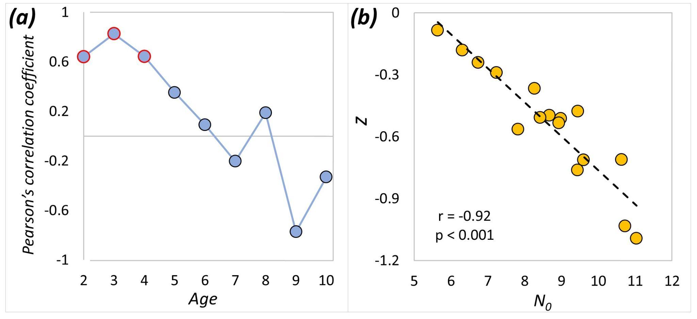

**Figure S2. (A)** Pearson’s correlation coefficients between *N0* and *N2-N10* for all generations. Significant correlations (p<0.05) are marked by symbols with red wrap. **(B)** Association between *N0* and *z* among generations. Pearson’s correlation coefficient (r) and p-value are given.

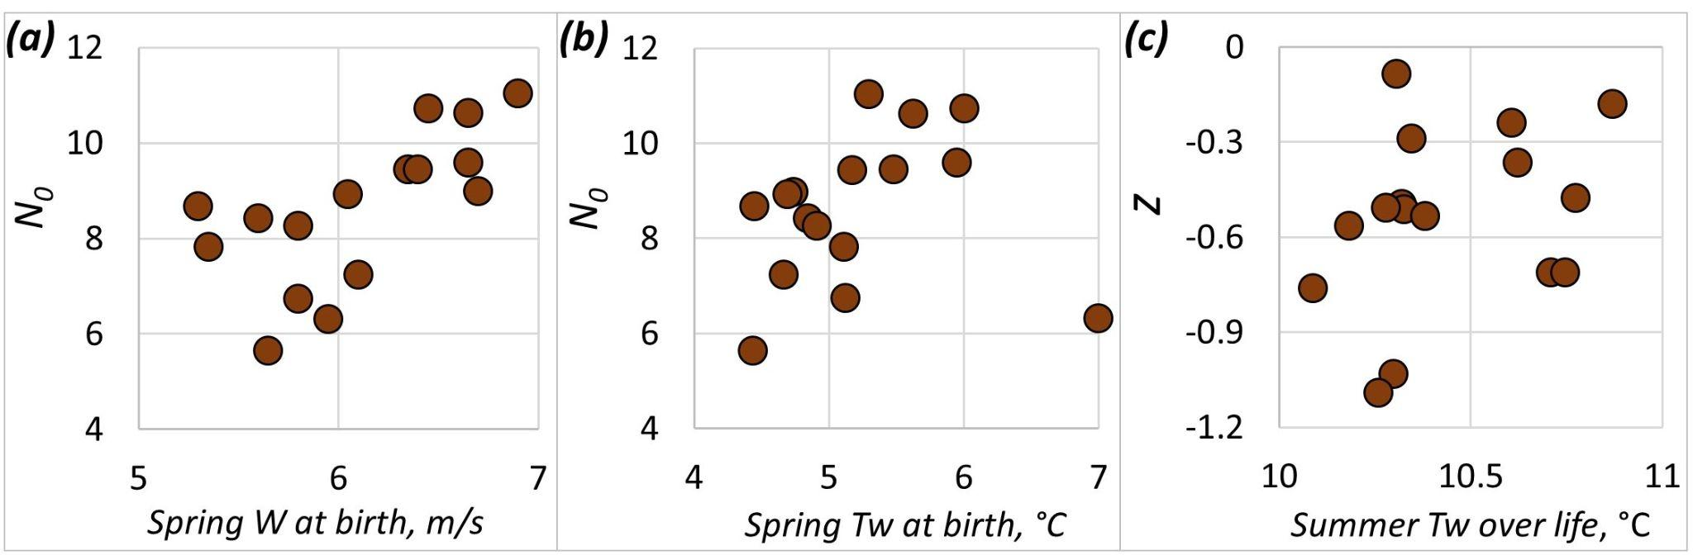

**Figure S3. The relationships between *N0*, *z* and selected environmental parameters.** **(A)** *N0* vs. wind speed in spring of the year of birth. **(B)** *N0* vs. surface water temperature in spring of the year of birth. **(C)** *z* vs. summer surface water temperature averaged over the lifespan.